# Introduction

## Our closest cousins

The kingdom Fungi is one of the most diverse groups of organisms on Earth, and they are integral ecosystem agents with a huge impact on biogeochemical cycles, plant and animal pathology, plant nutrition and soil properties. While historically clustered together with plants  (Copeland 1938, 1956), towards the middle of last century it started to become clear that this lumping failed to properly deal with the differences between the two groups. In 1969 R. H. Whittaker published a paper dividing the organisms into five kingdoms: Animalia, Plantae, Fungi, Protista and Monera  (Whittaker 1969). By the 70s this division became widely accepted, and the Kingdom Fungi was recognized. Acknowledgement is just the first step in knowledge though. The understanding of the taxonomy, evolution and phylogenesis of fungi was still a matter of ample debate, one of those that may never end for lack of evidence. All the analysis were based on morphological differences, with all of its downsides.

Fossilized fungi are very difficult to come by, as they do not biomineralize like animals do, and has proven not only inconclusive with regard to the origin of fungi, but also rather incomplete relative to the evolutionary history of the various fungal lineages. The earliest compendium of fossil fungi is from the late 19th century  (Meschinelli 1898), and the symbiotic relationship with plants in fossils was suggested around that period  (Renault 1896), but the difficulty in the interpretation of morphological data made it impossible to actually understand what happened.

Earliest fossil with the morphological features of a fungus is dated to around 1 billion years ago, and was found in the Arctic Canada  (Loron et al. 2019), and there is evidence of fungus-like organisms in fossils of around 800 Mya  (Bonneville et al. 2020). Those findings are rare though, we surely have a richer diversity of fossils from the lower Devonian (around 400 Mya).

It wasn’t until the large scale advent of molecular phylogenetics techniques that some light could be properly shed on the history of fungi  (James et al. 2006). From molecular clock analysis seems like fungi are sister group to animals, that is, the two lineages are close, diverging around 1.5 Billion years ago  (Wang, Kumar, and Hedges 1999). The two groups form one supergroup called Opisthokhonta  (Cavalier-Smith 1987), from the Greek opísthios (rear, posterior) and kontós (“pole” i.e. “flagellum”), since the group is characterized by flagellate cells that propel themselves with a single, posterior flagellum (in many cases lost).

IMG OF TREE WITH ANIMALS AND FUNGI AND PLANTS

## Ancient lovers

So: fungi are animals’ cousins, and the two lineage diverged around 1.5 billion years ago. What happened then?

The ancestors of fungi are believed to be simple aquatic forms with flagellated spores, similar to members of the extant phylum Chytridiomycota (chytrids), which are now considered one of the early-diverging clade in the kingdom  (James et al. 2006). The first terrestrial fungi colonized land probably before plants did  (Heckman et al. 2001), as saprobe (taking nutrition out of dead matter) and/or in symbiosis with organisms capable of photosynthesis. It is commonly accepted that in order to colonize the land, plants had to develop a symbiotic relationship with fungi  (Selosse and Le Tacon 1998; Heckman et al. 2001; Bonneville et al. 2020), but it is not entirely clear whether this relationship was lichen-like or mycorrhizal-like.

IMG LICHEN

Lichens are the symbiotic relationship between a singol or more fungi (*mycobiont*)and a cyanobacteria or algae (*photobyont*). Think about an algae floating in water: for many reasons, it is not really equipped to deal with the challenges of a terrestrial life style: mainly, it won’t be able to mine substrate resources, to protect itself against dehydration, constant direct UV radiations and strong temperature fluctuations  (Selosse and Le Tacon 1998; Blackwell 2000). In a lichen, the photobiont is protected by the fungal stroma, and it can tolerate drought, cold, heat, intense light and barren rocky substrates. They also seem to be the first pioneers in a barren environment today, so everything would point to them being the right candidate for a first out-of-water plant-fungi symbiosis.

Yet, while this relationship evolved several times  (Gargas et al. 1995), the only phyla we know that are capable of such process (called *lichenization*) are Ascomycota and, secondarly and later in time, Basidiomycota, and we can date the origin of those clades to about 400 Mya in the Devonian  (Berbee and Taylor 1993). Similarly we have fossils for lichens dating at the oldest in the Early Devonian (400 Mya)  (Taylor, Hass, and Kerp 1997; Honegger, Edwards, and Axe 2013), while the first fossil land plants and fungi appeared 480 to 460 Mya, and molecular clock estimates suggests about 600–700 Mya  (Berbee and Taylor 1993; Heckman et al. 2001).

Therefore, lichens were likely not what opened the way to plants for land colonization. Let’s look now at a mycorrhizal-like relationship.

Mycorrhiza is the symbiotic association between plants and fungi happening in the rhizosphere, that is, the plant’s root system. It consist in an exchange of resources between the fungus and the plant, ideally the plant providing sugar to the fungus and the fungus providing minerals and nutrients to the plant, even though it’s hard to pinpoint who’s benefiting who and it may fall on different scales of the parasithic-mutualistic spectrum

What we know is that fossils resembling mycorrhizal relationships have fossil dating back to the Ordovician (with an age of about 460 million years), and are Glomales-like Arbuscular Mychorrhizal (AM hereafter) fungi, in a moment where the land flora is supposed to only consist of plants on the bryophitic level  (Redecker, Kodner, and Graham 2000). Now, plants can photosynthetize; these fungi can extract minerals from the substrate with great efficiency, protect the root system, extend the range from which water can be taken and protect the plants from pathogens. It’s easy to see how this is going to end up in a passionate love story.

You could say “*wait a minute: those plants did not have true roots, how can we have a mycorrhizal relationship?*”. Good point. Fossil records provides evidence that fungal organisms entered in such symbiosis before the appearance of true roots, and as long as there is a multicellular host AM fungi are fine  (Wang and Qiu 2006; Bonfante and Genre 2008).

Whether as lichen or as mycorrhiza, the symbiosis between plants and fungi is one of the most important, most ancient relationship in the history of living beings and it surely played a crucial role in the successful colonization of the land by plants  (Pirozynski and Malloch 1975; Malloch, Pirozynski, and Raven 1980; Harley and Harley 1987; Trappe and Safir 1987; Selosse and Le Tacon 1998; Brundrett 2002). The relationship is so beneficial (for one or both parts) that today is the norm, and is well established in c. 85% of extant plants  (Cairney 2000; Strullu-Derrien et al. 2018), with a high degree of complexity  (Heijden et al. 2015) and mychorrizas networks often constitute 20%–30% of total soil microbial biomass  (Leake et al. 2011)

## Orchids

Let’s move the camera away from fungi for a second. Don’t worry, we’ll get back to them soon enough, but now we need to introduce the second protagonist of the present work: orchids. Orchids are a diverse and widespread family of flowering plants, counting over 28,000 species in about 736 genera  (Christenhusz and Byng 2016), second only to *asteraceae* in terms of number even though they got on the scene only around 80 Mya  (Ramírez et al. 2007), not very long ago. They are cosmopolitan, with a distribution spanning all continents except Antarctica and including most major island groups  (Givnish et al. 2016). By the end of 2017 the IUCN Global Red List included assessments for 948 orchid species, of which 56.5% are threatened  (Fay 2018). In Europe all wild orchids are protected, being included in their entirety on Appendices I and II of the Convention on International Trade in Endangered Species of Wild Fauna and Flora  (“Appendices | CITES,” n.d.) as are many of the habitats they live in, and are in many countries Red List. Nonetheless, this protection has not staved off a general decline in the orchid flora of Europe  (Jacquemyn et al. 2005; Kull and Hutchings 2006). Major threats include habitat destruction and unsustainable (often illegal) harvesting, and because of their complex life histories orchids are thought to be particularly vulnerable to the effects of global environmental change  (Kull et al. 2016; Gale et al. 2018)

Orchids exhibit an astonishing diversity of habitat adaptations, morphologies and pollination strategies, but some characteristics are common to the whole family. One of the most important is the reliance on Orchid Mycorrhizal Fungi (OMF hereafter) for reproduction and often outright survival. I told you we would soon get back to them. Orchids seeds are devoid of nutritional resources, and they completely rely on fungi for nutrition including water, minerals and carbon supply  (Leake 1994; RASMUSSEN and WHIGHAM 1998; Merckx 2013) in a nutritional strategy called “mycoheterotrophy”. After germination, seedlings often become autotrophic and subsequently revert to usual mycorrhizal functioning  (Rasmussen 1995; Cameron et al. 2008). Some species, especially from forest environments, remain mycoheterotrophic at adulthood though, developing partial photosynthetic capacity but still relying on fungi for carbon resources, a nutritional strategy called “mixotrophy” or “partial mycoheterotrophy”  (Gebauer and Meyer 2003; Julou et al. 2005; Selosse and Roy 2009). Others never develop photosynthetic capacity and therefore rely completely on fungi for nutrition. This nutritional mode, which has evolved over 30 times independently in orchids, is called “obligate mycoheterootrophy”  (Merckx 2013). So: no OMFs, no orchids.

While the relationship between orchids and OMFs is known since over a century  (Bernard 1899; Rayner 1927; Rasmussen 2002; Selosse, Boullard, and Richardson 2011) and the mechanisms of this symbiosis are beginning to be properly understood, the knowledge from a taxonomical standpoint is still in full evolution. For many years orchids were thought to interact almost entirely with the members of the *Rhizoctonia* complex. It was later discovered not only that orchids have way more interactions with different fungi also from the *Ascomycetes* phylum, but also that *rhizoctonia* is a polyphyletic group, and was disassembled in different taxa, all members of the *Agaricomycetes*, most notably ***Sebacinales, Ceratobasidiaceae*** and ***Tulasnellaceae***  (Dearnaley, Martos, and Selosse 2012). There is also evidence of fungi from the *Ascomycota* phylum, especially in the order *Pezizales*  (Selosse et al. 2004; Ouanphanivanh 2008; Waterman et al. 2011), but they are the exception rather than the rule: the most common and known families of OMFs are in the *Basidiomycota* phylum, especially *Inocybaceae*, *Tulasnellaceae*, *Ceratobasidiaceae*, *Russulaceae*, *Sebacinaceae*, *Serendipitaceae* and *Thelephoraceae*  (Taylor, Bruns, and Hodges 2004; Roy et al. 2009; Duffy et al. 2019)

### Distribution and ecology of OMFs

Since as we’ve seen orchids depend on OMFs for the germination of the seeds and in many cases for the nutrients also in adulthood, it is safe to assume that OMFs are everywhere orchids are. This is not the whole tale though, as we know that many OMFs can also turn to a soil free-living saprotrophic ecological niche  (Oberwinkler, Cruz, and Suárez 2017) and form mycorrhizal relationship with plants other than orchids  (Selosse and Martos 2014), allowing them to spread to a bigger area. *Tulasnellaceae, Ceratobasidiaceae,* and *Sebacinales*(*Serendipitaceae* and *Sebacinaceae*) are ubiquitous, varying in their contribution to the total amount of OMFs depending on the area and in the level of specialization for the orchids. Other families, even though less common, still have a presence in most of the world  (Jacquemyn, Duffy, and Selosse 2017).

This is all good and well as long as we look at the matter a broad scale. Here, the abiotic variables such as annual rainfall, soil chemistry etc. explain the distribution the best, but when we zoom at a more local level biotic factors, community composition and interactions may affect the OMFs distribution just as much, especially considering they are symbiotic organisms  (Jacquemyn, Duffy, and Selosse 2017). I used *may*, as there is a lack of evidence in this regard, and many parts of the world are dramatically undersampled (e.g. all the African continent and most of the tropical areas of the planet), so conclusions are often drew from a limited amount of very specific data. Part of the “problem” is how complex the relationships between orchids and OMFs are. They both vary in their degree of specialization, from a highly specialized to a more generalist approach  (McCormick, Whigham, and O’Neill 2004; Girlanda et al. 2011; Heijden et al. 2015), and OMFs can also turn to other ecologies, as pathogenic fungi and saprophitic free-living organisms  (Veldre et al. 2013). The community question it’s critical: do OMFs from different families occour in different habitats? How much do the biotic factors impact the OMFs distribution compared to abiotic factors? Do OMFs belonging to the same family occour in different habitat? How much does is the preference for an habitat a shared characteristic for a group? Giving a partial answer to those questions, in regard to Europe, is the main aim of the present work.

# Materials and methods

## The database

Data from bibliography regarding the distribution of OMFs in Europe was collected into a starting database. The data had to be of fungi isolated from known orchid roots, and had to be georeferenced at the very least with the name of a close enough place; also, each sample had to have a genbank accession code in order to get the sequences and do the analysis. Only sequences from well-known OMFs were considered, that is: Ceratobasidiaceae, Tulasnellaceae, Inocybaceae, Serendipitaceae, Sebacinaceae, Russulaceae and Thelephoraceae  (Dearnaley, Martos, and Selosse 2012). Orchid species sampled were Orchis anthropophora, Cephalanthera damasonium  (Julou et al. 2005), Cephalanthera longifolia  (Pecoraro et al. 2017), Orchis simia and Orchis simia  (Schatz et al. 2010; Lievens et al. 2010), Orchis tridentata  (Pecoraro et al. 2012), Orchis militaris  (Shefferson, Kull, and Tali 2008), Orchis purpurea  (Lievens et al. 2010), Himantoglossum adriaticum  (Pecoraro et al. 2013), Limodorum abortivum  (Girlanda et al. 2005), Spiranthes spiralis  (Duffy et al. 2019), Ophrys bertolonii  (Pecoraro et al. 2015), Neottia ovata  (Hans Jacquemyn et al. 2015; Těšitelová et al. 2015) Neottia cordata  (Těšitelová et al. 2015), Dactylorhiza baltica  (Shefferson, Kull, and Tali 2008) and Epipactis atrorubens  (Shefferson, Kull, and Tali 2008)

For each point six variables were extracted by using the ESDAC database  (“ESDAC - European Commission,” n.d.) and the World Clim database  (“WorldClim,” n.d.): Nitrogen, Potassium and Phosphorus soil content, soil pH, minimum temperature of the coldest quarter and maximum precipitation of the wettest month. Those variables were selected because there is evidence that mycorrhizal fungi are very sensitive to nutrients in the soil: Nitrogen, Phosphorus and Potassium in high quantities (such as in eutrophicated soils because of agricultural fertilizers) have been seen to cause decline in the belowground mycorrhizal fungi species richness and cause dramatic changes in the community composition and structure  (Lilleskov et al. 2002; Baar et al. 2002; Grant et al. 2011). Mycorrhizal fungi growth and community composition also seem to be influenced by the soil pH  (Aarle, Olsson, and Söderström 2002; Carrino-Kyker et al. 2016), temperature and precipitation  (Rillig, Treseder, and Allen 2003). That’s not all though: those variables may serve as important proxy for other conditions. Biomes and vegetation are correlated with the environmental condition, both because they change said conditions (like soil pH) and because all species have a range of tolerance. Also, human impact can often be seen by the amount of chemicals in the soil, especially close to cultivated fields. Environmental values were extracted using GDAL’s Sample Raster Values tool (Using QGIS v. 3.16 as a GUI) and appended to the dataset

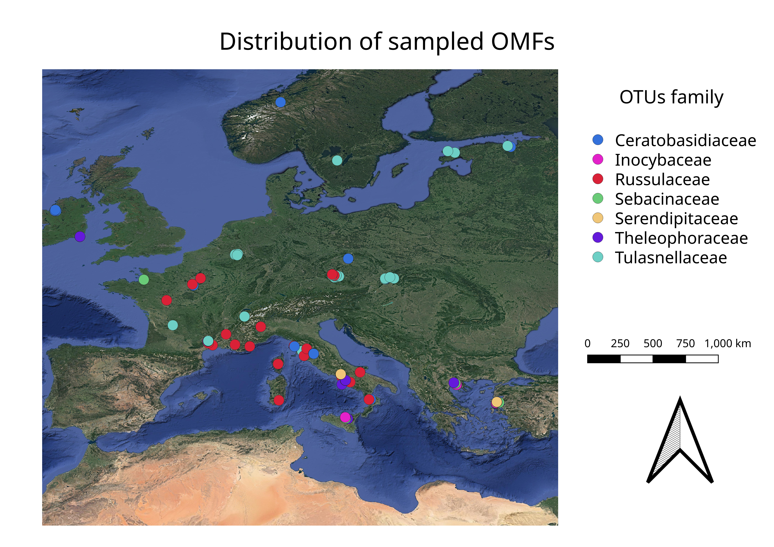

Sampled points

## Phylogenetic analysis

In order to understand the distribution and ecology of the OMFs we need to get a better insight of their phylogenesis. The hypothesis was for sequences of the same family to be clustered together, with some doubts with the Sebacinales as Serendipitaceae and Sebacinaceae are very close and only recently named so  (Weiß et al. 2016). The phylogenetic analysis were performed on the sequences deposited by the papers included in the database. The **primers** used were mainly ITS1F, ITS4, ITS3 and ITS4OF, all targeting **regions** between the 18S rRNA subunit and the 28S rRNA subunit, including the Internal Transcribed Spacers (ITS hereafter) 1 and ITS 2. Those primers were usually universal for *Basidiomycota* or in some cases more specific for *Tulasnellaceae* (like ITS4tul) or other taxa. Sequence DQ520100 from *Tremiscus helvelloides* was used as outgroup.

* Sequences were aligned using the MUSCLE algorithm  (Edgar 2004) and manually trimmed to a visually satisfying overlapping
* Ugene was used as main GUI, v. 37.0  (Okonechnikov et al. 2012)
* The Maximum Parsimony analysis was performed using TNT, v. 1.1  (“TNT, a Free Program for Phylogenetic Analysis - Goloboff - 2008 - Cladistics - Wiley Online Library,” n.d.), using the Tree Bisection and Reconnection algorhithm and with ten replics. 1000 trees were kept and a strict consensus tree was calculated. A bootstrap was performed on the tree with 200 replications to test the validity of the tree. Bootstrap values are displayed as node labels in the appendix tree
* The Bayesian analysis (MCMC) was performed using MrBayes, v. 3.2.7a  (Huelsenbeck and Ronquist 2001), using the Hasegawa-Kishino-Yano with a gamma rate heterogeneity among sites (lset nst=2 rates=gamma;). One million trees were generated and sampled each thousand, with four chains running. A final consensus tree was then calculated (see appendix)
* Trees were then visually edited with FigTree v. 1.4.4
* All parameters are available in the supplemental data, along with the files to reproduce the analysis.

## Multivariate analysis

Before proceeding with the multivariate analysis, sequences have been clustered into Operative Taxonomic Units (**OTU** hereafter), by using cd-hit v. 4.8.1  (Li, Jaroszewski, and Godzik 2001). This process yielded 210 OTUs, with the extremes of *Serendipitaceae* having two OTUs only, and *Tulasnellaceae* 52 OTUs. The database was then pivoted in a presence-absence matrix, and for further analysis it was splitted by family, so that each matrix only had all the OTUs for that single family, yielding 7 different matrices. This was necessary to test what internal variability each family has; another matrix was obtained by grouping together all the observations from the same family, to test what the variability between the different families is.

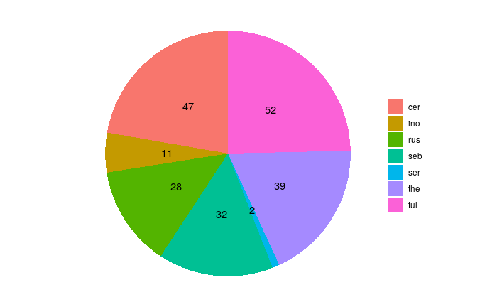

Number of OTUs from each family

A final matrix was obtained by using the single Families/OTUs as rows and removing the qualitaties orchid species variable. This was done to understand the impact of the environmental variables only on each OTU, therefore trying to understand how different the realized niche (ie variance in the environmental variables) is between the groups.

Principal Component Analysis (PCA hereafter) is an orthogonal linear transformation of the data that aims to maximize the variance of the scalar projection of all points of a dataset into a number of axis ordinated by explained variance. This yields a set of axis, which can be used for clustering, to reduce the number of dimensions and so on. PCA was performed on all matrices using the base R functions princomp(), which takes into account the covariance matrix and applies an eigen method of spectral decomposition when possible. Only in the case of Russulaceae, when the number of observation was too limited, prcomp() was used, which does a single value decomposition on the centered and scaled data matrix.

As of clustering, Non-metric Multi Dimensional Scaling (NMDS) is another widely used method that allows to visualize the level of similarity of individuals in a dataset. In contrast with PCA, it’s non-linear and it’s based on a distance matrix, computed by different algorithms depending on the data. It works better with non-parametric data, such as the present one. NMDS was performed on all the matrices by using the R package *vegan*  (Dixon 2003), to understand both how do the OTUs from different families cluster together (if they do) and what environmental factors are most relevant; the Euclidean distance method was used.

In both the PCA and the NMDS we have taken into account how each OTUs presence was influenced by environmental factors, such as climate and soil conditions, and how do they cluster together. Species Distribution Models (SDM hereafter) is another conceptual framework we can use to disentangle the assembly processes that lead to the community as we can observe from the data we have, and to infer the relative importance of the environmental factors. SDMs are numerical tools that combine observations of species occurrence or abundance with environmental estimates. They are used to gain ecological and evolutionary insights and to predict distributions across landscapes, sometimes requiring extrapolation in space and time  (Elith and Leathwick 2009); those models can also inform us of how species‐to‐species associations depend on the environmental context, in a Joint Species Distribution Model which oftentimes outperforms simple SDMs especially with sparse data  (Pollock et al. 2014; Tikhonov et al. 2017)

In the present work, a kind of JSDM called Hierarchical Model of Species Community (HMSC)  (Ovaskainen et al. 2017) was performed by using the Hmsc package in R, v. 3.0.9  (Tikhonov et al. 2020; hmsc-r 2021); this method uses a bayesian framework to find the best fitting model based on the data, and works very well with presence-absence data as well as with environmental data  (Hefley and Hooten 2016) Three parallel chains were run, sampling every 500 results. Regression was done with a probit model (probability + unit), a non-linear model where the dependent variable can only take two variables, which was particularly apt for this dataset because of the binary nature of the presence-absence matrix. Using this framework, a plot with the species responses to environmental covariates (beta parameters) was produced, with at least a 85% posterior probability of being positive (red) or negative (blue). In addition, by using the presence-absence matrix, a correlation plot between the OTUs was established, looking at the positive associations with a statistical support of at least 85% shown in red and negative associations shown in blue.

# Results

## Phylogenetic analysis

The **Bayesian analysis** yielded low probability branches. Nonetheless, it correctly put together the families, with the only notable exception of the *Serendipitaceae* and *Sebacinaceae* which were nested separately. This makes sense though, as they are both *Sebacinales* and the *serendipitaceae* were originally considered *sebacinaceae B*  (Weiss et al. 2004) and were only recently given a new name and properly defined  (Weiß et al. 2016) The **Maximum parsimony analysis** gave similar results, with very low bootstrap support

## PCA

The **PCA analysis** on the presence-absence matrix and the environmental variables combined showed how there is a substantial overlap of realized niche in the OTUs isolated from different orchids, without distinguishable clusterings except for the Tulasnellaceae isolated from Neottia cordata. In all cases, the variance was well explained by the first two components (>95% explained variance), with two variables bearing most of the loading: Maximum Precipitation of the wettest month and Potassium content in the soil.

The PCA done using the condensed family matrix yielded the same results, with the notable exception of the Limodorum abortivum, which a way higher variance than expected 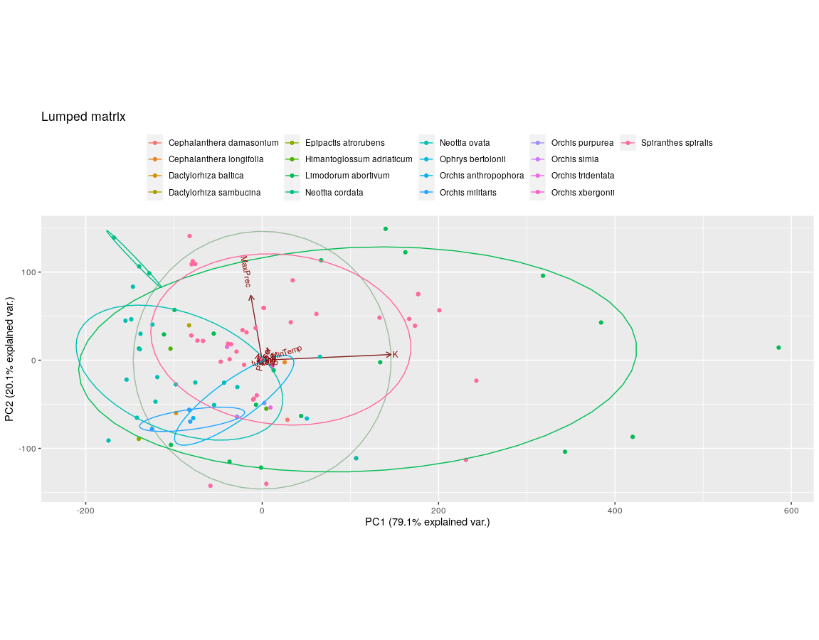

Condensed Matrix  
  
 PC1 PC2  
K 0.996  
MaxPrec 0.994  
  
  
Ceratobasidiaceae  
  
 PC1 PC2  
K -0.991 0.117   
MaxPrec 0.120 0.992   
  
Russulaceae  
  
 PC1 PC2  
K 0.995   
MaxPrec -0.994   
  
  
Theleophoraceae  
  
 PC1 PC2  
K 0.999   
MaxPrec 0.987

## NMDS

The **NMDS analysis** on the single families seems to show that there is no highly relevant differentiation in the OTUs found in different orchid species, as the clustering wasn’t really neat. Again, Tulasnellaceae seem to be the exception, with more distinct groups for different orchid hosts; while this could be a bias caused by the higher number of samples, Ceratobasidiaceae and Theleophoraceae did not show this pattern even though the sample amount where roughly similar. This could point to a higher specialization of the Tulasnellaceae group, confirming previous observations  (Dearnaley 2007) The NMDS campiring the families yielded only a partial overlapping clustering, which could indicate that different orchids may have different degrees of specialization and realized niche; Limodorum abortivum seemed to exibit the highest diversity, together with Spiranthes spiralis.

Taking the Orchid species out of the NMDS analysis and only looking at how different OMF families clustered based on the environmental conditions showed an unexpected pattern. Russulaceae seemed to have a way bigger variance, which points to a broader realized niche, compared to all other families; Tulasnellaceae, which is the most sampled and abundant OMF in the dataset, had less than half the variance and clustered in an area comparable to Sebacinaceae.

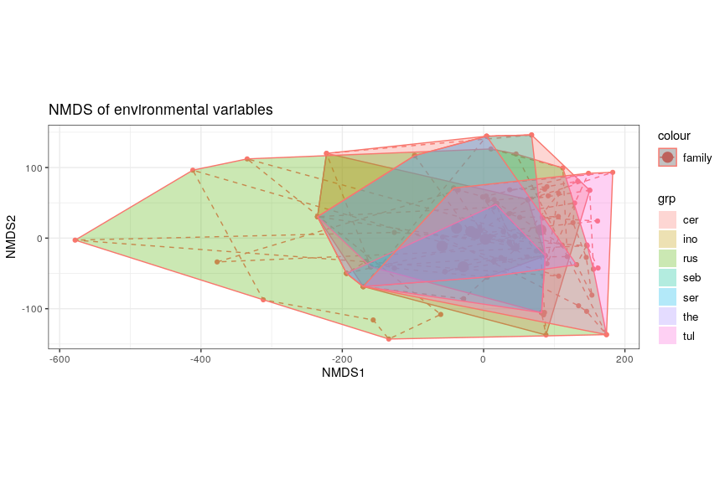

NMDS of the OMFs families considering environmental variables only

## HMSC

The **HMSC** yielded basically two results. In the correlation between the families seemed like most families had a positive correlation, with two exceptions: Tulasnellaceae, who had no correlation (0) and Russulaceae, that had a negative correlation (-1). Apparently, Russulaceae not only have a bigger niche, they also don’t share it. The mechanisms and reasons for such negative correlation could be interesting matter for future studies. OTUs from the same families seemed, on the other hand, to have no correlation with the others, positive or negative. This stands true for all families but Ceratobasidiaceae, which had more complex correlations, both positive and negative. Whether this is phylogenetically related is to be understood.

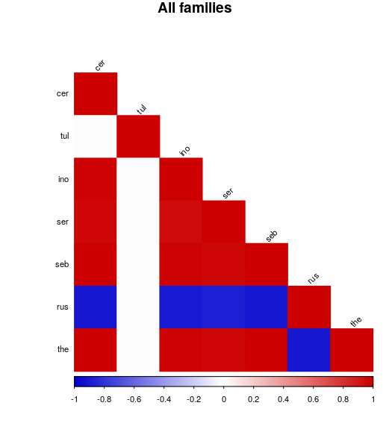

HMSC correlation between the families, taking into account the presence-absence data

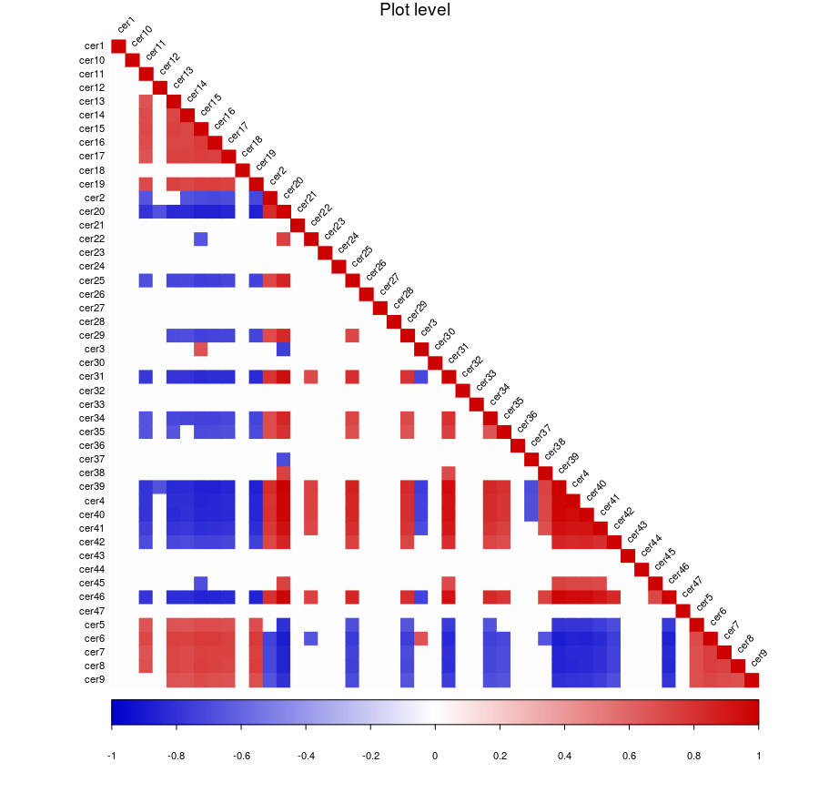

HMSC correlation between Ceratobasidiaceae OTUs

The second HMSC result is the correlation between the groups and the environmental variables. The difference between the families wasn’t very pronounced, and the most relevant parameter seemed the minimum temperature, which was highly correlated with most families (only Tulasnellaceae had 0 correlation), confirming the importance of this environmental parameter in understanding the distribution of OMFs. Maximum precipitation was also invertedly correlated with most families, except for Russulaceae which showed a positive correlation. Of all the soil parameters, pH seemed the most important with a general inverse correlation (the lower the pH, the higher the presence of the OMF). The differences between OTUS from the same families were less clear-cut, showing different correlations for different OTUs in the same family, giving an idea of the diversity that can happen also at low taxonomic levels. It’s worthy of notice that Tulasnellaceae showed again the least amount of internal differences, with Ceratobasidiaceae being at the opposite side of the spectrum.

# Discussion

The phylogenetic analysis yielded low quality trees, from which no useful data could be extracted. This is likely the result of the inconsistent overlap of the sequences. Many primers were used, and the resulting sequences were differently trimmed before depositing, with many partial sequences.

The PCA analysis was more fruitful. Together with NMDS it seemed to cluster together the fungi isolated from different orchid species, which would support the idea of the OMFs generalist approach as being the most common, which is a still ongoing debate  (Bailarote, Lievens, and Jacquemyn 2012). Also, variance was mainly explained by two main variables, Potassium and Maximum Precipitation, which means that those variables contribute the least to the definition of the niche and that the Orchids were living in places highly differenciated in those parameters. This could also be the result of the very broad sampling, and more research should be done on a smaller scale, as the Potsassium levels can dramatically vary even in a very small plot, doubling in just a few meters  (Bogunovic et al. 2014).

Russulaceae seemed from the NMDS to be more tolerant than other families to different environments, and despite the lower number of sampled individuals we witness a more widespread. This could mean that the Russulaceae are more generalist toward orchids, that they have a wider niche or that it’s more ecologically flexible, or all of the above. Russulaceae are a very diverse family, but it is actually difficult to say that Russulaceae find a “niche” in the symbiosis with orchids, especially with Limodorum, as there doesn’t seem to be any advantage for the fungus: this orchids seem to have an insufficient photosynthesis and to heavily rely on the OMFs to provide not only minerals but also carbon-base chemicals; this also means that distribution of Limodorum may also be potentially constrained by the occurrence of its fungal symbionts  (Girlanda et al. 2005).

The HMSC put the spotlight on Russulaceae again, with their negative correlation with the other families. This means that where we find Russulaceae, we are unlikely going to find other OMFs. This is probably the result of the main orchid species where Russulas were found in this dataset, Limodorum abortivum, which seems to show a specialization toward this family  (Girlanda et al. 2005). The rest of the data seem to confirm a major generalistic approach in the recruitment by orchids, also confirmed by the lack of any correlation between the different OTUs of the same family: the presence of one doesn’t seem to inhibit other OTUs from the same family to infect the root.

Aarle, Ingrid M. Van, Pål Axel Olsson, and Bengt Söderström. 2002. “Arbuscular Mycorrhizal Fungi Respond to the Substrate pH of Their Extraradical Mycelium by Altered Growth and Root Colonization.” *New Phytologist* 155 (1): 173–82. <https://doi.org/10.1046/j.1469-8137.2002.00439.x>.

“Appendices | CITES.” n.d. https://cites.org/eng/app/appendices.php.

Baar, J., T. Bastiaans, M. van de Coevering, and J. Roelofs. 2002. “Ectomycorrhizal Root Development in Wet Alder Carr Forests in Response to Desiccation and Eutrophication.” *Mycorrhiza* 12 (3). Springer: 147–51.

Bailarote, Bruno Cachapa, Bart Lievens, and Hans Jacquemyn. 2012. “Does Mycorrhizal Specificity Affect Orchid Decline and Rarity?” *American Journal of Botany* 99 (10): 1655–65. <https://doi.org/10.3732/ajb.1200117>.

Berbee, Mary L., and John W. Taylor. 1993. “Dating the Evolutionary Radiations of the True Fungi.” https://cdnsciencepub.com/doi/abs/10.1139/b93-131.

Bernard, Noel. 1899. “Sur La Germination Du Neottia Nidus-Avis.” *Comptes Rendus Hebdomadaires Des Séances de L’Académie Des Sciences, Paris* 128: 1253–5.

Blackwell, Meredith. 2000. “Terrestrial Life–Fungal from the Start?” *Science* 289 (5486). American Association for the Advancement of Science: 1884–5. <https://doi.org/10.1126/science.289.5486.1884>.

Bogunovic, Igor, Milan Mesic, Zeljka Zgorelec, Aleksandra Jurisic, and Darija Bilandzija. 2014. “Spatial Variation of Soil Nutrients on Sandy-Loam Soil.” *Soil and Tillage Research* 144 (December): 174–83. <https://doi.org/10.1016/j.still.2014.07.020>.

Bonfante, Paola, and Andrea Genre. 2008. “Plants and Arbuscular Mycorrhizal Fungi: An Evolutionary-Developmental Perspective.” *Trends in Plant Science* 13 (9): 492–98. <https://doi.org/10.1016/j.tplants.2008.07.001>.

Bonneville, S., F. Delpomdor, A. Préat, C. Chevalier, T. Araki, M. Kazemian, A. Steele, A. Schreiber, R. Wirth, and L. G. Benning. 2020. “Molecular Identification of Fungi Microfossils in a Neoproterozoic Shale Rock.” *Science Advances* 6 (4). American Association for the Advancement of Science: eaax7599. <https://doi.org/10.1126/sciadv.aax7599>.

Brundrett, Mark C. 2002. “Coevolution of Roots and Mycorrhizas of Land Plants.” *New Phytologist* 154 (2): 275–304. <https://doi.org/10.1046/j.1469-8137.2002.00397.x>.

Cairney, J. W. G. 2000. “Evolution of Mycorrhiza Systems.” *Naturwissenschaften* 87 (11). Springer: 467–75.

Cameron, Duncan D., Irene Johnson, David J. Read, and Jonathan R. Leake. 2008. “Giving and Receiving: Measuring the Carbon Cost of Mycorrhizas in the Green Orchid, Goodyera Repens.” *New Phytologist* 180 (1): 176–84. <https://doi.org/10.1111/j.1469-8137.2008.02533.x>.

Carrino-Kyker, Sarah R., Laurel A. Kluber, Sheryl M. Petersen, Kaitlin P. Coyle, Charlotte R. Hewins, Jared L. DeForest, Kurt A. Smemo, and David J. Burke. 2016. “Mycorrhizal Fungal Communities Respond to Experimental Elevation of Soil pH and P Availability in Temperate Hardwood Forests.” *FEMS Microbiology Ecology* 92 (fiw024). <https://doi.org/10.1093/femsec/fiw024>.

Cavalier-Smith, T. 1987. “The Origin of Fungi and Pseudofungi.” In *Evolutionary Biology of the FUngi, British Mycological Society Symposium*, 12:339–53. Cambridge Univ. Press.

Christenhusz, Maarten J. M., and James W. Byng. 2016. “The Number of Known Plants Species in the World and Its Annual Increase.” *Phytotaxa* 261 (3): 201–17. <https://doi.org/10.11646/phytotaxa.261.3.1>.

Copeland, Herbert F. 1938. “The Kingdoms of Organisms.” *The Quarterly Review of Biology* 13 (4). The University of Chicago Press: 383–420. <https://doi.org/10.1086/394568>.

Copeland, H. F. 1956. “The Classification of Lower Organisms.” *The Classification of Lower Organisms.* Palo Alto, California, Pacific Books.

Dearnaley, J. D. W., F. Martos, and M.-A. Selosse. 2012. “12 Orchid Mycorrhizas: Molecular Ecology, Physiology, Evolution and Conservation Aspects.” In *Fungal Associations*, edited by Bertold Hock, 207–30. Berlin, Heidelberg: Springer Berlin Heidelberg. <https://doi.org/10.1007/978-3-642-30826-0_12>.

Dearnaley, John D. W. 2007. “Further Advances in Orchid Mycorrhizal Research.” *Mycorrhiza* 17 (6): 475–86. <https://doi.org/10.1007/s00572-007-0138-1>.

Dixon, Philip. 2003. “VEGAN, a Package of R Functions for Community Ecology.” *Journal of Vegetation Science* 14 (6): 927–30. <https://doi.org/10.1111/j.1654-1103.2003.tb02228.x>.

Duffy, Karl J., Michael Waud, Bertrand Schatz, Theodora Petanidou, and Hans Jacquemyn. 2019. “Latitudinal Variation in Mycorrhizal Diversity Associated with a European Orchid.” *Journal of Biogeography* 46 (5): 968–80. <https://doi.org/10.1111/jbi.13548>.

Edgar, Robert C. 2004. “MUSCLE: Multiple Sequence Alignment with High Accuracy and High Throughput.” *Nucleic Acids Research* 32 (5). Oxford University Press: 1792–7.

Elith, Jane, and John R. Leathwick. 2009. “Species Distribution Models: Ecological Explanation and Prediction Across Space and Time.” *Annual Review of Ecology, Evolution, and Systematics* 40 (1). Annual Reviews: 677–97. <https://doi.org/10.1146/annurev.ecolsys.110308.120159>.

“ESDAC - European Commission.” n.d. https://esdac.jrc.ec.europa.eu/.

Fay, Michael F. 2018. “Orchid Conservation: How Can We Meet the Challenges in the Twenty-First Century?” *Botanical Studies* 59 (1): 16. <https://doi.org/10.1186/s40529-018-0232-z>.

Gale, Stephan W, Gunter A Fischer, Phillip J Cribb, and Michael F Fay. 2018. “Orchid Conservation: Bridging the Gap Between Science and Practice.” *Botanical Journal of the Linnean Society* 186 (4): 425–34. <https://doi.org/10.1093/botlinnean/boy003>.

Gargas, A., P. T. DePriest, M. Grube, and A. Tehler. 1995. “Multiple Origins of Lichen Symbioses in Fungi Suggested by SSU rDNA Phylogeny.” *Science* 268 (5216). American Association for the Advancement of Science: 1492–5. <https://doi.org/10.1126/science.7770775>.

Gebauer, G., and M. Meyer. 2003. “15N and 13C Natural Abundance of Autotrophic and Myco-Heterotrophic Orchids Provides Insight into Nitrogen and Carbon Gain from Fungal Association.” *New Phytologist* 160 (1): 209–23. <https://doi.org/10.1046/j.1469-8137.2003.00872.x>.

Girlanda, Mariangela, Rossana Segreto, Donata Cafasso, Heiko Tobias Liebel, Michele Rodda, Enrico Ercole, Salvatore Cozzolino, Gerhard Gebauer, and Silvia Perotto. 2011. “Photosynthetic Mediterranean Meadow Orchids Feature Partial Mycoheterotrophy and Specific Mycorrhizal Associations.” *American Journal of Botany* 98 (7): 1148–63. <https://doi.org/10.3732/ajb.1000486>.

Girlanda, M., M. A. Selosse, D. Cafasso, F. Brilli, S. Delfine, R. Fabbian, S. Ghignone, et al. 2005. “Inefficient Photosynthesis in the Mediterranean Orchid Limodorum Abortivum Is Mirrored by Specific Association to Ectomycorrhizal Russulaceae: MYCORRHIZAL SPECIFICITY IN LIMODORUM.” *Molecular Ecology* 15 (2): 491–504. <https://doi.org/10.1111/j.1365-294X.2005.02770.x>.

Givnish, Thomas J., Daniel Spalink, Mercedes Ames, Stephanie P. Lyon, Steven J. Hunter, Alejandro Zuluaga, Alfonso Doucette, et al. 2016. “Orchid Historical Biogeography, Diversification, Antarctica and the Paradox of Orchid Dispersal.” *Journal of Biogeography* 43 (10): 1905–16. <https://doi.org/10.1111/jbi.12854>.

Grant, Cynthia, Shabtai Bittman, Marcia Montreal, Christian Plenchette, and Christian Morel. 2011. “Soil and Fertilizer Phosphorus: Effects on Plant P Supply and Mycorrhizal Development.” *Canadian Journal of Plant Science*, March. NRC Research Press Ottawa, Canada. <https://doi.org/10.4141/P03-182>.

Hans Jacquemyn, Michael Waud, Vincent S. F. T. Merckx, Bart Lievens, and Rein Brys. 2015. “Mycorrhizal Diversity, Seed Germination and Long-Term Changes in Population Size Across Nine Populations of the Terrestrial Orchid Neottia Ovata.” *Molecular Ecology* 24 (13): 3269–80. <https://doi.org/10.1111/mec.13236>.

Harley, J. L., and E. L. Harley. 1987. “A Check-List of Mycorrhiza in the British Flora.” *The New Phytologist* 105 (2). [Wiley, New Phytologist Trust]: 1–102.

Heckman, Daniel S., David M. Geiser, Brooke R. Eidell, Rebecca L. Stauffer, Natalie L. Kardos, and S. Blair Hedges. 2001. “Molecular Evidence for the Early Colonization of Land by Fungi and Plants.” *Science* 293 (5532). American Association for the Advancement of Science: 1129–33. <https://doi.org/10.1126/science.1061457>.

Hefley, Trevor J., and Mevin B. Hooten. 2016. “Hierarchical Species Distribution Models.” *Current Landscape Ecology Reports* 1 (2): 87–97. <https://doi.org/10.1007/s40823-016-0008-7>.

Heijden, Marcel G. A. van der, Francis M. Martin, Marc-André Selosse, and Ian R. Sanders. 2015. “Mycorrhizal Ecology and Evolution: The Past, the Present, and the Future.” *New Phytologist* 205 (4): 1406–23. <https://doi.org/10.1111/nph.13288>.

hmsc-r. 2021. “Hmsc-R/HMSC.”

Honegger, Rosmarie, Dianne Edwards, and Lindsey Axe. 2013. “The Earliest Records of Internally Stratified Cyanobacterial and Algal Lichens from the Lower Devonian of the Welsh Borderland.” *New Phytologist* 197 (1): 264–75. <https://doi.org/10.1111/nph.12009>.

Huelsenbeck, John P., and Fredrik Ronquist. 2001. “MRBAYES: Bayesian Inference of Phylogenetic Trees.” *Bioinformatics* 17 (8). Oxford University Press: 754–55.

Jacquemyn, Hans, Rein Brys, Martin Hermy, and Jo H. Willems. 2005. “Does Nectar Reward Affect Rarity and Extinction Probabilities of Orchid Species? An Assessment Using Historical Records from Belgium and the Netherlands.” *Biological Conservation* 121 (2): 257–63. <https://doi.org/10.1016/j.biocon.2004.05.002>.

Jacquemyn, Hans, Karl J. Duffy, and Marc-André Selosse. 2017. “Biogeography of Orchid Mycorrhizas.” In *Biogeography of Mycorrhizal Symbiosis*, edited by Leho Tedersoo, 159–77. Ecological Studies. Cham: Springer International Publishing. <https://doi.org/10.1007/978-3-319-56363-3-8>.

James, Timothy Y., Frank Kauff, Conrad L. Schoch, P. Brandon Matheny, Valérie Hofstetter, Cymon J. Cox, Gail Celio, et al. 2006. “Reconstructing the Early Evolution of Fungi Using a Six-Gene Phylogeny.” *Nature* 443 (7113). Nature Publishing Group: 818–22. <https://doi.org/10.1038/nature05110>.

Julou, Thomas, Bastian Burghardt, Gerhard Gebauer, Daniel Berveiller, Claire Damesin, and Marc-André Selosse. 2005. “Mixotrophy in Orchids: Insights from a Comparative Study of Green Individuals and Nonphotosynthetic Individuals of Cephalanthera Damasonium.” *New Phytologist* 166 (2): 639–53. <https://doi.org/10.1111/j.1469-8137.2005.01364.x>.

Kull, Tiiu, and Michael J. Hutchings. 2006. “A Comparative Analysis of Decline in the Distribution Ranges of Orchid Species in Estonia and the United Kingdom.” *Biological Conservation* 129 (1): 31–39. <https://doi.org/10.1016/j.biocon.2005.09.046>.

Kull, Tiiu, Ulvi Selgis, Miguel Villoslada Peciña, Mirjam Metsare, Aigi Ilves, Kadri Tali, Kalev Sepp, Kalevi Kull, and Richard P. Shefferson. 2016. “Factors Influencing IUCN Threat Levels to Orchids Across Europe on the Basis of National Red Lists.” *Ecology and Evolution* 6 (17): 6245–65. <https://doi.org/10.1002/ece3.2363>.

Leake, Jonathan, David Johnson, Damian Donnelly, Gemma Muckle, Lynne Boddy, and David Read. 2011. “Networks of Power and Influence: The Role of Mycorrhizal Mycelium in Controlling Plant Communities and Agroecosystem Functioning.” *Canadian Journal of Botany*, February. NRC Research Press Ottawa, Canada. <https://doi.org/10.1139/b04-060>.

Leake, Jonathan R. 1994. “The Biology of Myco-Heterotrophic (‘Saprophytic’) Plants.” *New Phytologist* 127 (2): 171–216. <https://doi.org/10.1111/j.1469-8137.1994.tb04272.x>.

Li, W., L. Jaroszewski, and A. Godzik. 2001. “Clustering of Highly Homologous Sequences to Reduce the Size of Large Protein Databases.” *Bioinformatics (Oxford, England)* 17 (3): 282–83. <https://doi.org/10.1093/bioinformatics/17.3.282>.

Lievens, Bart, Stefan van Kerckhove, Annelies Justé, Bruno P.A. Cammue, Olivier Honnay, and Hans Jacquemyn. 2010. “From Extensive Clone Libraries to Comprehensive DNA Arrays for the Efficient and Simultaneous Detection and Identification of Orchid Mycorrhizal Fungi.” *Journal of Microbiological Methods* 80 (1): 76–85. <https://doi.org/10.1016/j.mimet.2009.11.004>.

Lilleskov, Erik A., Timothy J. Fahey, Thomas R. Horton, and Gary M. Lovett. 2002. “Belowground Ectomycorrhizal Fungal Community Change over a Nitrogen Deposition Gradient in Alaska.” *Ecology* 83 (1): 104–15. [https://doi.org/10.1890/0012-9658(2002)083[0104:BEFCCO]2.0.CO;2](https://doi.org/10.1890/0012-9658(2002)083%5B0104:BEFCCO%5D2.0.CO;2).

Loron, Corentin C., Camille François, Robert H. Rainbird, Elizabeth C. Turner, Stephan Borensztajn, and Emmanuelle J. Javaux. 2019. “Early Fungi from the Proterozoic Era in Arctic Canada.” *Nature* 570 (7760). Nature Publishing Group: 232–35. <https://doi.org/10.1038/s41586-019-1217-0>.

Malloch, D. W., K. A. Pirozynski, and P. H. Raven. 1980. “Ecological and Evolutionary Significance of Mycorrhizal Symbioses in Vascular Plants (A Review).” *Proceedings of the National Academy of Sciences* 77 (4). National Academy of Sciences: 2113–8. <https://doi.org/10.1073/pnas.77.4.2113>.

McCormick, M. K., D. F. Whigham, and J. O’Neill. 2004. “Mycorrhizal Diversity in Photosynthetic Terrestrial Orchids.” *New Phytologist* 163 (2): 425–38. <https://doi.org/10.1111/j.1469-8137.2004.01114.x>.

Merckx, Vincent SFT. 2013. “Mycoheterotrophy: An Introduction.” In *Mycoheterotrophy*, 1–17. Springer.

Meschinelli, Luigi. 1898. *Fungorum Fossilium Omnium: Hucusque Cognitorum Iconographia*. Sumptibus auctoris, typis Aloysii Fabris.

Oberwinkler, Franz, Darío Cruz, and Juan Pablo Suárez. 2017. “Biogeography and Ecology of Tulasnellaceae.” In *Biogeography of Mycorrhizal Symbiosis*, edited by Leho Tedersoo, 237–71. Ecological Studies. Cham: Springer International Publishing. <https://doi.org/10.1007/978-3-319-56363-3_12>.

Okonechnikov, Konstantin, Olga Golosova, Mikhail Fursov, and the UGENE team. 2012. “Unipro UGENE: A Unified Bioinformatics Toolkit.” *Bioinformatics* 28 (8): 1166–7. <https://doi.org/10.1093/bioinformatics/bts091>.

Ouanphanivanh, Noémi. 2008. “Could Orchids Indicate Truffle Habitats? : Mycorrhizal Association Between Orchids and Truffles.” *Acta Biologica Szegediensis* 52 (1): 229–32.

Ovaskainen, Otso, Gleb Tikhonov, Anna Norberg, F. Guillaume Blanchet, Leo Duan, David Dunson, Tomas Roslin, and Nerea Abrego. 2017. “How to Make More Out of Community Data? A Conceptual Framework and Its Implementation as Models and Software.” *Ecology Letters* 20 (5): 561–76. <https://doi.org/10.1111/ele.12757>.

Pecoraro, Lorenzo, Mariangela Girlanda, Tiiu Kull, Claudia Perini, and Silvia Perotto. 2012. “Analysis of Fungal Diversity in Orchis Tridentata Scopoli.” *Central European Journal of Biology* 7 (5): 850–57. <https://doi.org/10.2478/s11535-012-0071-y>.

———. 2013. “Fungi from the Roots of the Terrestrial Photosynthetic Orchid Himantoglossum Adriaticum.” *Plant Ecology and Evolution* 146 (2): 145–52. <https://doi.org/10.5091/plecevo.2013.782>.

Pecoraro, Lorenzo, Mariangela Girlanda, Zhong-Jian Liu, Laiqiang Huang, and Silvia Perotto. 2015. “Molecular Analysis of Fungi Associated with the Mediterranean Orchid Ophrys Bertolonii Mor.” *Annals of Microbiology* 65 (4): 2001–7. <https://doi.org/10.1007/s13213-015-1038-9>.

Pecoraro, Lorenzo, Laiqiang Huang, Tancredi Caruso, Silvia Perotto, Mariangela Girlanda, Lei Cai, and Zhong-Jian Liu. 2017. “Fungal Diversity and Specificity in Cephalanthera Damasonium and C. Longifolia (Orchidaceae) Mycorrhizas.” *Journal of Systematics and Evolution* 55 (2): 158–69. <https://doi.org/10.1111/jse.12238>.

Pirozynski, K. A., and D. W. Malloch. 1975. “The Origin of Land Plants: A Matter of Mycotrophism.” *Biosystems* 6 (3): 153–64. <https://doi.org/10.1016/0303-2647(75)90023-4>.

Pollock, Laura J., Reid Tingley, William K. Morris, Nick Golding, Robert B. O’Hara, Kirsten M. Parris, Peter A. Vesk, and Michael A. McCarthy. 2014. “Understanding Co-Occurrence by Modelling Species Simultaneously with a Joint Species Distribution Model (JSDM).” *Methods in Ecology and Evolution* 5 (5): 397–406. <https://doi.org/10.1111/2041-210X.12180>.

Ramírez, Santiago R., Barbara Gravendeel, Rodrigo B. Singer, Charles R. Marshall, and Naomi E. Pierce. 2007. “Dating the Origin of the Orchidaceae from a Fossil Orchid with Its Pollinator.” *Nature* 448 (7157). Nature Publishing Group: 1042–5. <https://doi.org/10.1038/nature06039>.

Rasmussen, Hanne N. 1995. *Terrestrial Orchids: From Seed to Mycotrophic Plant*. Cambridge University Press.

———. 2002. “Recent Developments in the Study of Orchid Mycorrhiza.” *Plant and Soil* 244 (1/2). Springer: 149–63.

RASMUSSEN, HANNE N., and DENNIS F. WHIGHAM. 1998. “The Underground Phase: A Special Challenge in Studies of Terrestrial Orchid Populations.” *Botanical Journal of the Linnean Society* 126 (1-2): 49–64. <https://doi.org/10.1111/j.1095-8339.1998.tb02515.x>.

Rayner, M. C. 1927. “Mycorrhiza. An Account of Non-Pathogenic Infection by Fungi in Vascular Plants and Bryophytes.” *Mycorrhiza. An Account of Non-Pathogenic Infection by Fungi in Vascular Plants and Bryophytes.*, no. No. 15. Wheldon & Wesley.

Redecker, Dirk, Robin Kodner, and Linda E. Graham. 2000. “Glomalean Fungi from the Ordovician.” *Science* 289 (5486). American Association for the Advancement of Science: 1920–1. <https://doi.org/10.1126/science.289.5486.1920>.

Renault, Bernard. 1896. *Bassin Houiller et Permien d’Autun et d’Épinac: Flore Fossile, 2. Partie. Fascicule 4*. Vol. 4. Imprimerie nationale.

Rillig, Matthias C., Kathleen K. Treseder, and Michael F. Allen. 2003. “Global Change and Mycorrhizal Fungi.” In *Mycorrhizal Ecology*, edited by Marcel G. A. van der Heijden and Ian R. Sanders, 135–60. Ecological Studies. Berlin, Heidelberg: Springer. <https://doi.org/10.1007/978-3-540-38364-2_6>.

Roy, Melanie, Takahiro Yagame, Masahide Yamato, Koji Iwase, Christine Heinz, Antonella Faccio, Paola Bonfante, and Marc-Andre Selosse. 2009. “Ectomycorrhizal Inocybe Species Associate with the Mycoheterotrophic Orchid Epipogium Aphyllum but Not Its Asexual Propagules.” *Annals of Botany* 104 (3): 595–610. <https://doi.org/10.1093/aob/mcn269>.

Schatz, Bertrand, Alexandre Geoffroy, Benjamin Dainat, Jean-Marie Bessière, Bruno Buatois, Martine Hossaert-McKey, and Marc-André Selosse. 2010. “A Case Study of Modified Interactions with Symbionts in a Hybrid Mediterranean Orchid.” *American Journal of Botany* 97 (8): 1278–88. <https://doi.org/10.3732/ajb.0900303>.

Selosse, M.-A., A. Faccio, G. Scappaticci, and P. Bonfante. 2004. “Chlorophyllous and Achlorophyllous Specimens of Epipactis Microphylla (Neottieae, Orchidaceae) Are Associated with Ectomycorrhizal Septomycetes, Including Truffles.” *Microbial Ecology* 47 (4). <https://doi.org/10.1007/s00248-003-2034-3>.

Selosse, M-A, and F Le Tacon. 1998. “The Land Flora: A Phototroph-Fungus Partnership?” *Trends in Ecology & Evolution* 13 (1): 15–20. <https://doi.org/10.1016/S0169-5347(97)01230-5>.

Selosse, Marc-André, Bernard Boullard, and David Richardson. 2011. “Noël Bernard (18741911): Orchids to Symbiosis in a Dozen Years, One Century Ago.” *Symbiosis* 54 (2): 61–68. <https://doi.org/10.1007/s13199-011-0131-5>.

Selosse, Marc-André, and Florent Martos. 2014. “Do Chlorophyllous Orchids Heterotrophically Use Mycorrhizal Fungal Carbon?” *Trends in Plant Science* 19 (11): 683–85. <https://doi.org/10.1016/j.tplants.2014.09.005>.

Selosse, Marc-André, and Mélanie Roy. 2009. “Green Plants That Feed on Fungi: Facts and Questions About Mixotrophy.” *Trends in Plant Science* 14 (2): 64–70. <https://doi.org/10.1016/j.tplants.2008.11.004>.

Shefferson, Richard P., Tiiu Kull, and Kadri Tali. 2008. “Mycorrhizal Interactions of Orchids Colonizing Estonian Mine Tailings Hills.” *American Journal of Botany* 95 (2): 156–64. <https://doi.org/10.3732/ajb.95.2.156>.

Strullu-Derrien, Christine, Marc-André Selosse, Paul Kenrick, and Francis M. Martin. 2018. “The Origin and Evolution of Mycorrhizal Symbioses: From Palaeomycology to Phylogenomics.” *New Phytologist* 220 (4): 1012–30. <https://doi.org/10.1111/nph.15076>.

Taylor, D. Lee, Thomas D. Bruns, and Scott A. Hodges. 2004. “Evidence for Mycorrhizal Races in a Cheating Orchid.” *Proceedings of the Royal Society of London. Series B: Biological Sciences* 271 (1534). Royal Society: 35–43. <https://doi.org/10.1098/rspb.2003.2557>.

Taylor, Thomas N., Hagen Hass, and Hans Kerp. 1997. “A Cyanolichen from the Lower Devonian Rhynie Chert.” *American Journal of Botany* 84 (7): 992–1004. <https://doi.org/10.2307/2446290>.

Těšitelová, Tamara, Milan Kotilínek, Jana Jersáková, François-Xavier Joly, Jiří Košnar, Irina Tatarenko, and Marc-André Selosse. 2015. “Two Widespread Green Neottia Species (Orchidaceae) Show Mycorrhizal Preference for Sebacinales in Various Habitats and Ontogenetic Stages.” *Molecular Ecology* 24 (5): 1122–34. <https://doi.org/10.1111/mec.13088>.

Tikhonov, Gleb, Nerea Abrego, David Dunson, and Otso Ovaskainen. 2017. “Using Joint Species Distribution Models for Evaluating How Species-to-Species Associations Depend on the Environmental Context.” *Methods in Ecology and Evolution* 8 (4): 443–52. <https://doi.org/10.1111/2041-210X.12723>.

Tikhonov, Gleb, Øystein H. Opedal, Nerea Abrego, Aleksi Lehikoinen, Melinda M. J. de Jonge, Jari Oksanen, and Otso Ovaskainen. 2020. “Joint Species Distribution Modelling with the R-Package Hmsc.” *Methods in Ecology and Evolution* 11 (3): 442–47. <https://doi.org/10.1111/2041-210X.13345>.

“TNT, a Free Program for Phylogenetic Analysis - Goloboff - 2008 - Cladistics - Wiley Online Library.” n.d. https://onlinelibrary.wiley.com/doi/full/10.1111/j.1096-0031.2008.00217.x.

Trappe, J. M., and G. R. Safir. 1987. “Ecophysiology of VA Mycorrhizal Plants.” CRC Press.

Veldre, Vilmar, Kessy Abarenkov, Mohammad Bahram, Florent Martos, Marc-Andre Selosse, Heidi Tamm, Urmas Kõljalg, and Leho Tedersoo. 2013. “Evolution of Nutritional Modes of Ceratobasidiaceae (Cantharellales, Basidiomycota) as Revealed from Publicly Available ITS Sequences.” *Fungal Ecology* 6 (4): 256–68. <https://doi.org/10.1016/j.funeco.2013.03.004>.

Wang, B., and Y.-L. Qiu. 2006. “Phylogenetic Distribution and Evolution of Mycorrhizas in Land Plants.” *Mycorrhiza* 16 (5): 299–363. <https://doi.org/10.1007/s00572-005-0033-6>.

Wang, D Y, S Kumar, and S B Hedges. 1999. “Divergence Time Estimates for the Early History of Animal Phyla and the Origin of Plants, Animals and Fungi.” *Proceedings of the Royal Society B: Biological Sciences* 266 (1415): 163–71.

Waterman, Richard J., Martin I. Bidartondo, Jaco Stofberg, Julie K. Combs, Gerhard Gebauer, Vincent Savolainen, Timothy G. Barraclough, and Anton Pauw. 2011. “The Effects of Above- and Belowground Mutualisms on Orchid Speciation and Coexistence.” *The American Naturalist* 177 (2). The University of Chicago Press: E54–E68. <https://doi.org/10.1086/657955>.

Weiss, Michael, Marc-André Selosse, Karl-Heinz Rexer, Alexander Urban, and Franz Oberwinkler. 2004. “Sebacinales: A Hitherto Overlooked Cosm of Heterobasidiomycetes with a Broad Mycorrhizal Potential* *Part 221 of the Series Studies in Heterobasidiomycetes from the Botanical Institute, University of Tübingen, Tübingen.” *Mycological Research* 108 (9): 1003–10. <https://doi.org/10.1017/S0953756204000772>.

Weiß, Michael, Frank Waller, Alga Zuccaro, and Marc-André Selosse. 2016. “Sebacinales One Thousand and One Interactions with Land Plants.” *New Phytologist* 211 (1): 20–40. <https://doi.org/10.1111/nph.13977>.

Whittaker, Robert H. 1969. “New Concepts of Kingdoms of Organisms.” *Science* 163 (3863): 150–60.

“WorldClim.” n.d. https://www.worldclim.org/.